WATSON DEEP LEARNING FOR FINDING MISSING PERSONS

INTRODUCTION

A **missing person** is a person who has disappeared and whose status as alive or dead cannot be

confirmed as their location and condition are not known. A person may go missing through a

voluntary disappearance, or else due to an accident, crime, death in a location where they cannot be

found (such as at sea), or many other reasons. In most parts of the world, a missing person will

usually be found quickly. While criminal abductions are some of the most widely reported missing

person cases, these account for only 2–5% of missing children in Europe.

By contrast, some missing person cases remain unresolved for many years. Laws related to these

cases are often complex since, in many jurisdictions, relatives and third parties may not deal with a

person's assets until their death is considered proven by law and a formal death certifificate issued.

The situation, uncertainties, and lack of closure or a funeral resulting when a person goes missing

may be extremely painful with long-lasting effects on family and friends

in this project we are going learn how we gone fifind the missing person using watson deep learning

**Watson Discovery** is an award-winning enterprise search tool and AI search

technology that breaks open data silos and retrieves specific answers to your questions

while analyzing trends and relationships buried in enterprise data.

From this project we can find the missing person using watson deep learning when the

person is missed form various locality

LITEARTURE SURVEY

Each year approximately 100000 peoples gets lost in India. In some cases lost person

gets found easily, but in some critical cases missing persons are never reunited with

their relatives. Finding lost person can be diffiffifficult task.

The currently available Manual System for fifinding missing person have very long

procedure and takes more time. More time is require for launching an FIR (First

Information Report) in police station. Also time required for fifinding lost person is more.

Also during manual process number of manpower for searching lost person is less. And

in some missing person related website they required FIR No for upload complaint on

their website.The web-database is a system where the web server will store the data in

table format where the data are fifilled in column and other parameters. There are

n-numbers of database available in the market but for this system we have used MySQL

since it’s an open source relational database management system. It also widely used

by web application developers, together with PHP and APACHE. MySQL is a three layer

model they are Application layer, Logical layer and Physical layer.THEORITICAL ANALYSIS

A. Hardware Requirement:

Processor: Intel 1.66GHz Processor Pentium 4 RAM: 256MB Hard disk: 80GB Device: GPRS

enabled Mobile Phone with Android OS B.

Software Requirement:

1) Eclipse or Android Studio

2) SDK for Android API 8 & Higher

3) JDK:

4) XAMPP Server with APACHE and MYSQL

Proposed System will contain following features:

Display Information about missing person.

Adding new complaint.

Removing Complaints.

Searching person by particular attribute such as name, location etc.

Notifification Portal.

1. Block Diagram/ Architecture:

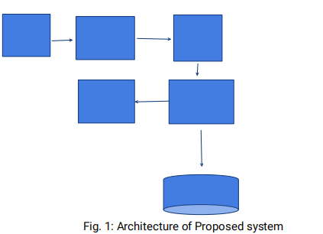

1) Presentation Layer: It is front end component, which is responsible for providing portable

presentation logic. Mobile phone will act as thin client. Phone will contain Application. User will interact with application to add complaint and send this data to web service

2) Business Layer (Web Service): The business layer function (web service) between

presentation layer and Database layer sending the client’s request to database. Web service will

be responsible to fetch data from client, process it and then store it in database. Web service

act as middleware for Application and Database. In our project used JSON web service for

connectivity.

3) Database Layer: Database is responsible for storing all information in well-defifined format.

Also it responses to the queries fifired by client to add, update, remove or search records. In Our

project we have used PHP

, MYSQL database for storing Information.

Work Flow Chart for User:

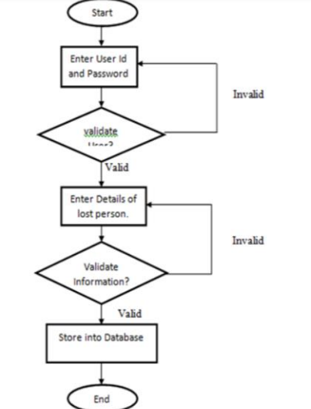

Advantages of Proposed System over Existing System:

Easy to upload and view Complaint.

All trust users can add complaint.

Simple GUI.

Easy to view informationDisadvantages of Proposed System:

Require Internet connection.

Require android phone with camera.

WORKING AND EXPERIMENTAL RESULTS

Our App is named as “Missing person fifinder” as the app is opened fifirst a window is opened

showing two options

1)User registration tab and

2) User login tab. User can register on the app by entering details using Name,Age ,UserID and

Password. User can directly login to app using UserID and password .As the user is logged in

the app will show two windows one for missing persons and second for found persons with

their details such as Photo, Name, Age, Address, Contact no. In missing person window list of

all missing peoples with their details will be shown there, An upload button is also provided in

that window where user can upload data of missing persons with their Name, Photo, Age,

Address. In found person window list of all found peoples with their details will be shown there,

An upload button is also provided in that window where user can upload data of found persons

with their Name, Photo, Age, Address

RESULTS

when we open jupyter notebook we run all code.when we import all libaries we dont get an error.

Login successful when correct credentials are entered App shows error message when wrong

UserID is entered and make login only when correct credentials are entered. App shows error

message when wrong Password is entered and make login only when correct credentials are

entered. App shows error message when numerical values are entered at the place of name.

App shows error message when alphabets are entered at the place of age. App shows error

message when incorrect date is entered

we use twilio app to detect the person

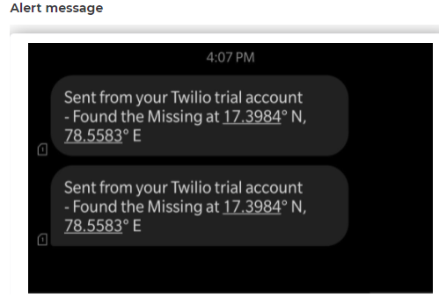

FUTURE SCOPE

The future work on which we are focusing now is to implement and measure the performance

of our proposed system so that we can justify that our proposed system is better in Finding

Missing Person than all the previous proposed system. Also we are going to add following

features in future to improve functionality of our system. Automatically periodic report

generation and Automatic Data Backup.

CONCLUSION

An effort is made towards recognition of face and the obtained recognition accuracy is much.

This method will be very benefificial for fifinding missing person. This application will upload

complaint on web server which can be accessed by any of the trust member having this

application. This project Finding Missing Person using Face Detection on Android Application

presents the solution for this problem. We are using four modules User, Police, Compliant

holder, Admin for getting appropriate result. Admin continuously Update database and Delete

unnecessary data.

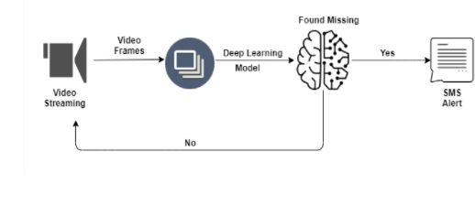

REFERANCE

[1] Lowe D G. Object recognition from local scale-invariant features. In: Proc. of the International

Conference on Computer Vision. Corfu, Greece, 1999 [2] Ke Y, Sukthankar R. PCA-SIFT: A more

distinctive representation for local image descriptors. In:Proc. of the IEEE Computer Society

Conference on Computer Vision and Pattern Recognition.Washington DC, USA, 2004. [3] Kisku D

R, Tistarelli M, Sing J K, et al. Face recognition by fusion of local and global matching scores

using DS theory: An evaluation with uni-classififier and multiclassififier paradigm. In: Proc. of IEEE

Computer Vision and Pattern Recognition (CVPR) Workshop on Biometrics. Miami, USA,2009.

[4] Lowe D G. Distinctive image features from scale invariant keypoints. International Journal of

Computer Vision, 2004 [5] Fredlund. Benac Earle. Marino, J. PropertyBased testing of JSONBasedWeb Service: Web service (ICWS) 2014 IEEE Inernational Conference [6] Mumtaz AL

Mukhtar, Sharmad Hadi Developing a Three Tier web data Management Application for Higher

Admission Environment-International Arab Journal ofe- Technology,Vol.2,No.4,june 2012 [7]

MCIA missing person Alert Android Application On Google play [8] Missing Child Android Application [9] http://missingperson.ap.nic.in/ [10] http://developer.android.com/ 11]

https://wiki.servicenow.com/index.php?title =JS

APPENDIX

